Week 2
Problem 1
Using tkinter, this problem creates a class with a simple initialiser and self parameter. Within this class a window is created through the tkinter library with some simple text. The window is given a title.
The “tkinter.mainloop()” is used to keep the gui open and the “my_gui = myGUI()” at the bottom launches the gui.
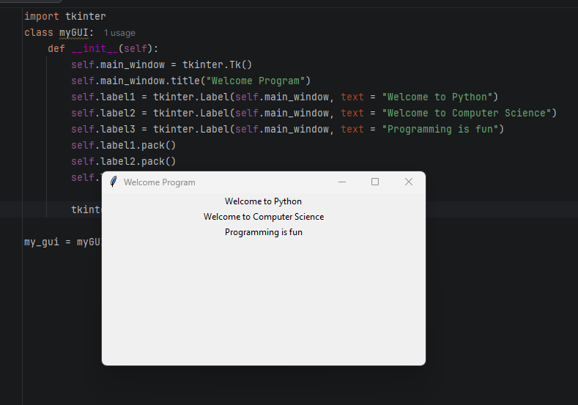
Problem 2
Similarly to the first program this uses tkinter to create a gui. Unlike the last program this solves the equation stored in result (9.5 * 4.5 - 2.5 * 3) / (45.5 - 3.5) as a float. This is then converted to a string (str(result)) and printed as a tkinter label.
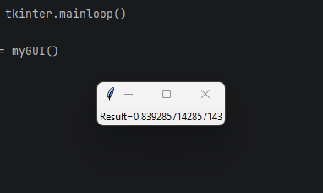
Problem 3
Almost the same as the 2nd problem although with a negative result
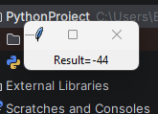
Problem 4
Same as last one with a different equation
